**RESPONSI PRAKTIKUM SCPK**

NAMA : AGUNG RIVALZO

NIM : 123190017

PLUG : E

(Jum’at, 25 Juni 2021 – Sabtu, 26 Juni 2021)

1. **Weighted Product (WP)**
2. Link Github WP : <https://github.com/agungrivqlzo/E_123190017_ResponsiSCPK>
3. Langkah pembuatan program dan penjelasan (yang penting-penting saja)

Contoh:

x = readtable('DATA Real Estate.xlsx','Range','C1:H51');

x(:,4:5) = []; % data cleaning

x = x{:,:}; % mengubah tipe tabel menjadi matriks

disp(x);

k = [0,0,1,0]; % nilai kriteria cost, cost, benefit, cost

w = [3,5,4,1]; % bobot sesuai soal

[m,n]=size (x); %inisialisasi ukuran x

w = w./sum(w); % normalisasi bobot

% proses

for j=1:n

if k(j)==0

w(j)=-1*w(j);

end

end

for i=1:m

S(i) = prod(x(i,:).^w);

if isinf(S(i)) % biar gaada nilai infinite

S(i) = 0;

end

end

V = S/sum(S);

% mencari nilai tertinggi

[val, idx] = sort(V, 'descend');

disp("max value :");

disp(val(1:5));

disp("index :");

disp(idx(1:5));

1. Pembuktian (dibuktikan dengan perhitungan manual, 5 ranking teratas)

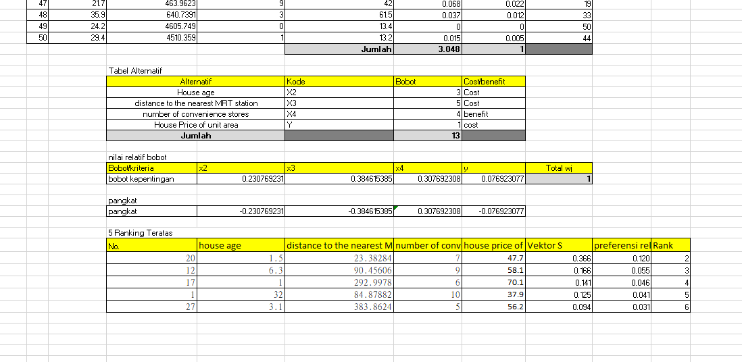

1. **Simple Additive Wighting (SAW)**
2. Link Github SAW : <https://github.com/agungrivqlzo/E_123190017_ResponsiSCPK>
3. Langkah pembuatan program dan penjelasan (yang penting-penting saja)

Contoh:

opts = detectImportOptions('DATA Rumah.xlsx');

opts.SelectedVariableNames = (1);

data1 = readmatrix('DATA Rumah.xlsx',opts);

opts = detectImportOptions('DATA Rumah.xlsx');

opts.SelectedVariableNames = (3:8);

data2 = readmatrix('DATA Rumah.xlsx',opts);

%data dimaksukan ke tabel 1

data = [data1 data2];

set(handles.uitable1,'data',data);

opts = detectImportOptions('DATA Rumah.xlsx');

opts.SelectedVariableNames = (3:8);

x = readmatrix('DATA Rumah.xlsx',opts);

k=[0,1,1,1,1,1];%nilai atribut, 0(cost) dan 1(benefit)

w=[0.30,0.20,0.23,0.10,0.07,0.10];%bobot

[m,n]=size (x);

R=zeros (m,n);

for j=1:n

if k(j)==1

%menghitung normalisasi kriteria jenis keuntungan

R(:,j)=x(:,j)./max(x(:,j));

else

%menghitung normalisasi kriteria jenis biaya

R(:,j)=min(x(:,j))./x(:,j);

end

end

%perhitungan hasil perankingan

for i=1:m

V(i)= sum(w.*R(i,:));

end

%menampilkan hasil perhitungan rumah

Vtranspose=V.';

Vtranspose=num2cell(Vtranspose);

opts = detectImportOptions('DATA Rumah.xlsx');

opts.SelectedVariableNames = (2);

x2= readtable('DATA Rumah.xlsx',opts);

x2 = table2cell(x2);

x2=[x2 Vtranspose];

x2=sortrows(x2,-2);

x2 = x2(1:20,1:2);

%data perhitungan dimasukan ke tabel 2

set(handles.uitable2, 'data', x2, 'visible','on');

1. Screenshot GUI

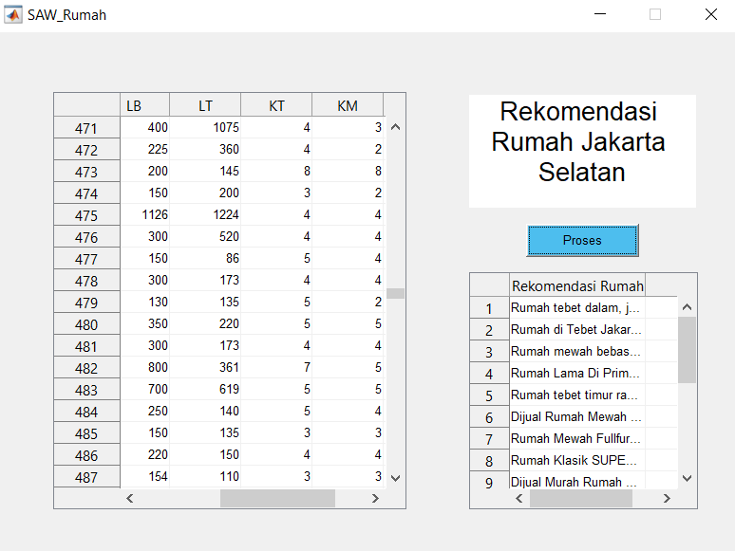

1. Pembuktian (dibuktikan dengan perhitungan manual, 5 ranking rumah teratas)

